UPLINK CONVERTER
function payloadDecoder(payload, metadata) {

var values = {};

for (var i = 0; i < payload.length;) {

var channel = payload[i++];
var type = payload[i++];

// Battery (WS203 + W202)
if (channel === 0x01 && type === 0x75) {

var battery = payload[i];

if (battery >= 0 && battery <= 100) {
values.battery = battery;
}

i += 1;
}

// Temperature (WS203)
else if (channel === 0x03 && type === 0x67) {

var temp = (payload[i] | (payload[i + 1] << 8));

if (temp > 32767) {
temp -= 65536;
}

values.temperature = temp / 10;
i += 2;
}

// PIR Status (W202)
else if (channel === 0x03 && type === 0x00) {

values.pir =
payload[i] === 1 ? "trigger" : "normal";

values.motion =
payload[i] === 1 ? 1 : 0;

i += 1;
}

// Humidity (WS203)
else if (channel === 0x04 && type === 0x68) {

values.humidity = payload[i] / 2;
i += 1;
}

// Daylight (W202)
else if (channel === 0x04 && type === 0x00) {

values.daylight =
payload[i] === 1 ? "bright" : "dim";

i += 1;
}

// Occupancy (WS203)
else if (channel === 0x05 && type === 0x00) {

values.occupancy = payload[i];

values.motion =
payload[i] === 1 ? 1 : 0;

i += 1;
}

else {
i += 1;
}
}

return {
telemetry: {
ts: metadata.ts,
values: values
},
attributes: {}
};
}

return payloadDecoder(payload, metadata);

TELEMETRY
battery motion occupancy temperature humidity event motion_triggered pir daylight

https://thingsboard.cloud/api/v1/integrations/loriot/3afb6073-de85-032c-6333-d916a694a7e6
DOWNLINK CONVERTER
var hexData = msg.payloadHex != null ? msg.payloadHex : "030111";

return {
contentType: "JSON",
data: hexData,
metadata: {
EUI: "A8404137E260FE7E",
port: 2,
isHexEncoded: "true"
}
};
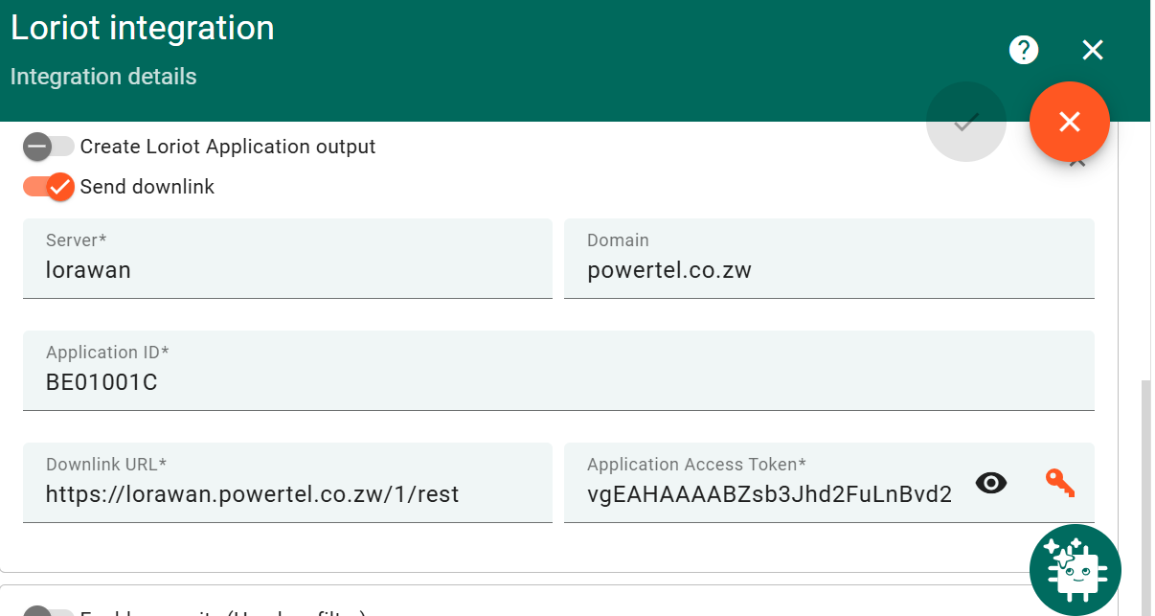

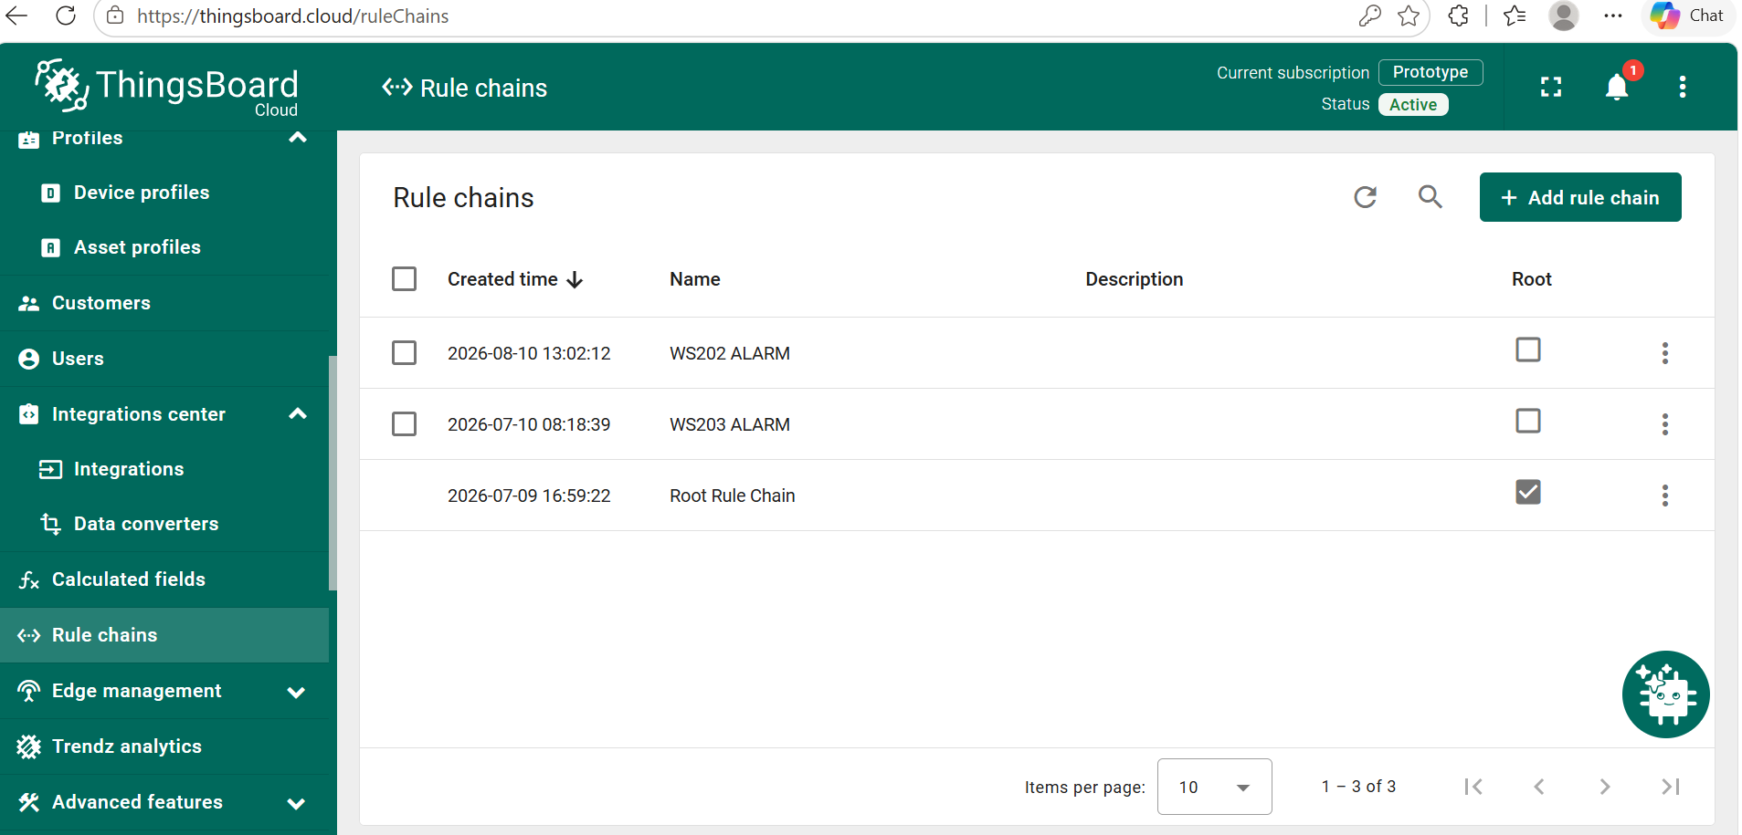
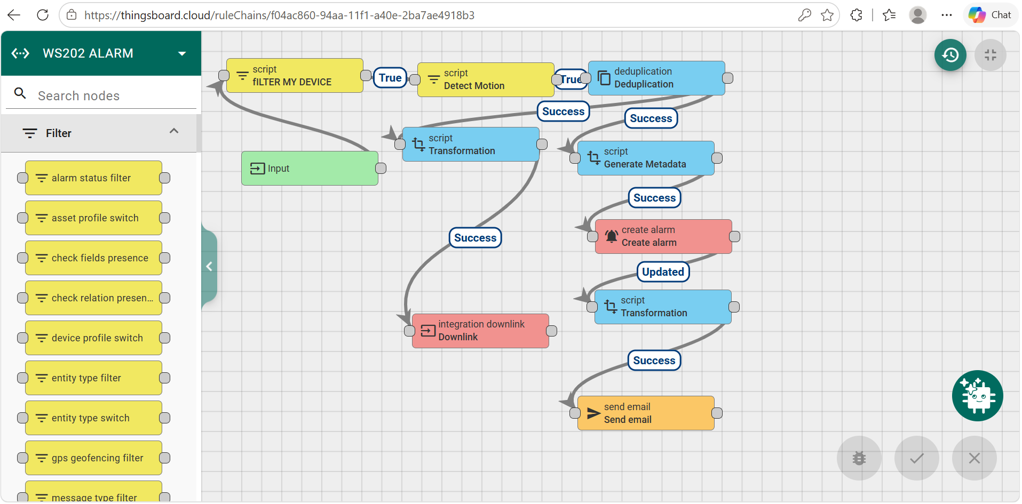

FILTER MY DEVICE
return metadata.deviceName != null &&
metadata.deviceName === "Device 24E124538F080118";

detect motion

var motion;
if (msg.motion != null) {
motion = msg.motion;
} else {
motion = msg.data.motion;
}

if (motion != 1 && motion !== "1" && motion !== true) {
return false;
}

return true;

DEDUPLICATION =10SEC

GENERATE META DAT
metadata.subject = "Motion Alert - Transformer Site";
metadata.body = "Motion detected on device: " + metadata.deviceName +
"\nTime: " + new Date(parseInt(metadata.ts)).toString() +
"\nTemperature: " + msg.temperature + "°C" +
"\nHumidity: " + msg.humidity + "%" +
"\nBattery: " + msg.battery;

return {msg: msg, metadata: metadata, msgType: msgType};

CREATE ALARM
var details = {};
if (metadata.prevAlarmDetails) {
details = JSON.parse(metadata.prevAlarmDetails);
//remove prevAlarmDetails from metadata
delete metadata.prevAlarmDetails;
//now metadata is the same as it comes IN this rule node
}

return details;

transformation

return {
msg: {
to: "carinine31@gmail.com, fardzanai@gmail.com, tichgandanhamo@gmail.com",
subject: "Motion Detected",
body: "Motion detected from " + metadata.deviceName
},
metadata: metadata,
msgType: "SEND_EMAIL"
};

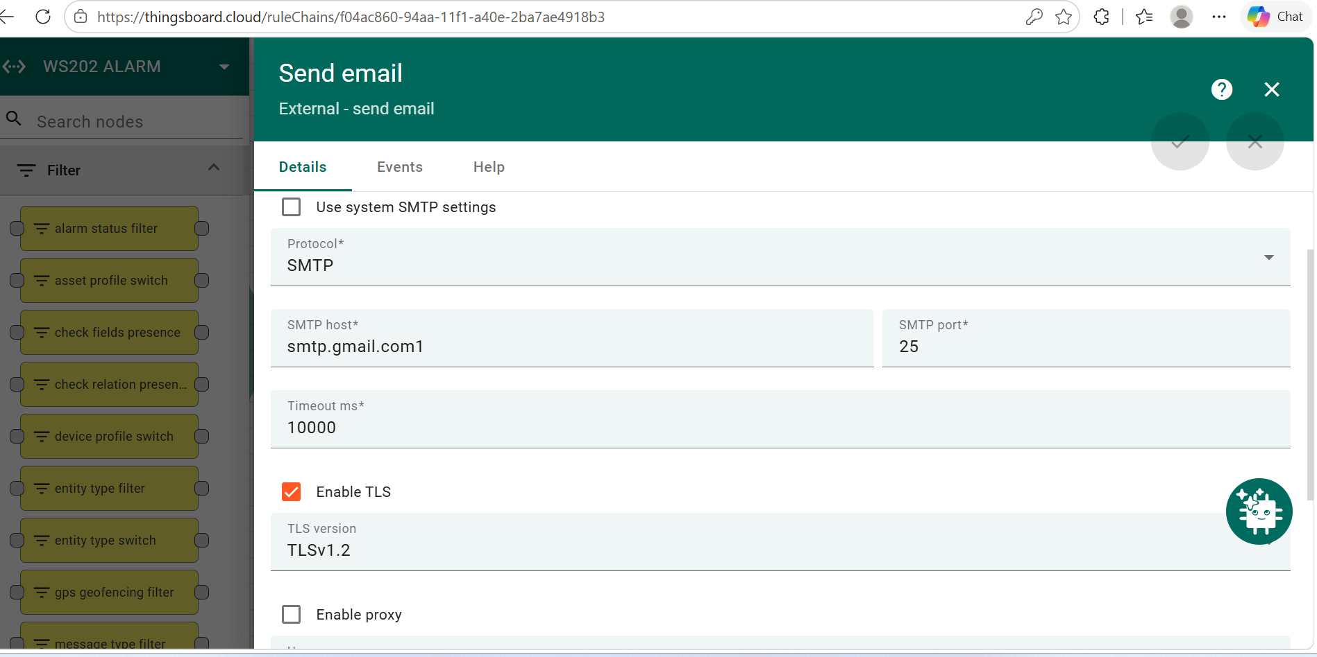

Transformation for downlink from deduplication
msg.payloadHex = "030111";

return {
msg: msg,
metadata: metadata,
msgType: msgType
};

Then downlink

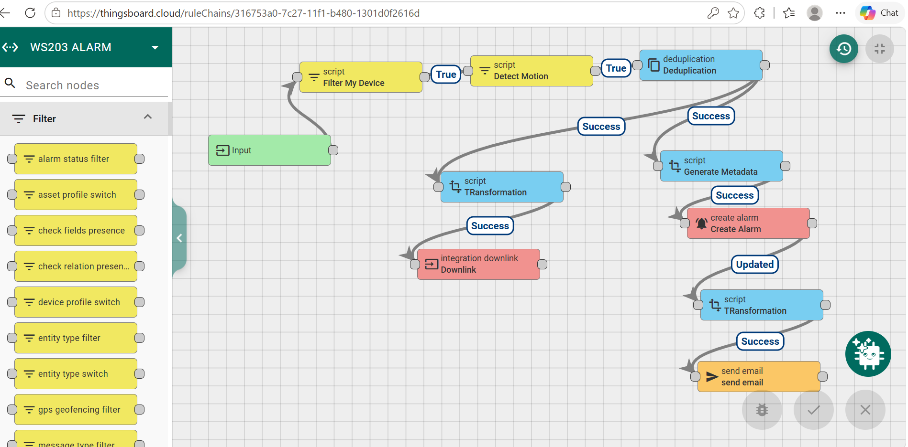

FILTER MY DEVICE
return metadata.deviceName != null &&
metadata.deviceName === "Device 24E124791F271780";

DETECT MOTION
var motion;
if (msg.motion != null) {
motion = msg.motion;
} else {
motion = msg.data.motion;
}

if (motion != 1 && motion !== "1" && motion !== true) {
return false;
}

return true;

DEDUPLICATION 10SEC

GENERATE METADATA

metadata.subject = "Motion Alert - Transformer Site";
metadata.body = "Motion detected on device: " + metadata.deviceName +
"\nTime: " + new Date(parseInt(metadata.ts)).toString() +
"\nTemperature: " + msg.temperature + "°C" +
"\nHumidity: " + msg.humidity + "%" +
"\nBattery: " + msg.battery;

return {msg: msg, metadata: metadata, msgType: msgType};

CREATE ALARM
var details = {};
if (metadata.prevAlarmDetails) {
details = JSON.parse(metadata.prevAlarmDetails);
//remove prevAlarmDetails from metadata
delete metadata.prevAlarmDetails;
//now metadata is the same as it comes IN this rule node
}

return details;

TRANSFORMATION
return {
msg: {
to: "carinine31@gmail.com, Fardzanai@gmail.com, tichgandanhamo@gmail.com",
subject: "Motion Detected",
body: "Motion detected from " + metadata.deviceName
},
metadata: metadata,
msgType: "SEND_EMAIL"
};

SEND EMAIL

FROR DOWNLINK FROM DEDUPLICATION
TRANSFORMATION
msg.payloadHex = "030111";

return {
msg: msg,
metadata: metadata,
msgType: msgType
};

DOWNLINK

